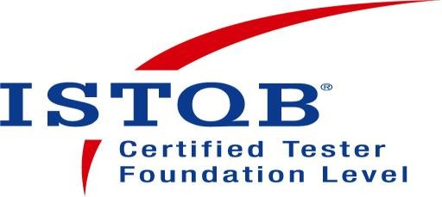
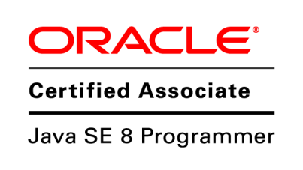
Your Name
(Can Join Immediately)
+91 XXXXX XXXXX

xyz@gmail.com

OBJECTIVE

To work in an environment which gives equal opportunities to expand my knowledge and to develop my career in innovative and challenging field of software testing with my commitment of contributing full effort & skills towards the organization.

PROFESSIONAL SUMMARY

- Having 4+ Years of Experience in Quality Assurance.
- Hands on Experience in Automation with Selenium WebDriver with Java.
- Have done various kinds of Testing including but not limited to Build Verification Testing, Functional Testing, Integration Testing, Browser Compatibility Testing, Exploratory Testing, Regression Testing , etc.
- Have been member of Interview Panel of the Organization since last Two years.
- Well Versed with SDLC, STLC, Defect Tracking, Defect Reporting and Defect Management.
- Good Knowledge in preparing various Test Artifacts like Test Scenarios, Test Cases, Test Plan, Regression Cycle Status Report, etc.
- Having Good Knowledge of Agile Methodology.
- Have mentored Junior and Fresher members of the Team.
- Have done Team Management.
- Having exposure to Performance Testing using JMeter.
- Strong in Communication and have actively participated in all the Project Meetings.
________________________________________________________

WORK EXPERIENCE

- Have worked as a Sr. Product Engineer-QA at ABC LLC. Location from May,2014 to Oct,2018.

________________________________________________________________________ BASIC ACADEMIC CREDENTIALS

QUALIFICATION | BOARD/UNIVERSITY | YEAR | PERCENTAGE
B.E. (I.T.) |  | 2013 | 6.87 CGPA
H.S.C. |  | 2009 | 59.20%
S.S.C. |  | 2007 | 74.15%

___________________________________________________________________

TECHNICAL PROFICIENCY
- Operating Systems: Windows 7/8/10, Linux
- Languages: Core Java, Shell Scripting
- DBMS/RDBMS: MySQL, MySQL Server
- Version Control: Git

Cloud Platform: AWS
- Tools: Selenium WebDriver, Eclipse, JIRA, TestLink, Selenium IDE, JMeter, Putty, Office Suites.
- Automation: Selenium WebDriver, TestNG, Maven, Jenkins

PROJECT DETAILS

(1) Project Name

• Project Description: It is a Web Application for computer assisted coding for US healthcare.

(2) Project name

• Project Description: It is a Web Application for clinical documentation improvement for US healthcare.

(3) Project Name

• Project Description: It is a Web Application for compliance/audit for US healthcare.

(4) Project Name

• Project Description: It is a Web Application which provides real time insights of data for US healthcare hospitals.

(5) Project Name

• Project Description: It is a Web Application for clinical documentation improvement for US healthcare without integration of document workflow.

(6) Project Name

- Project Description: It is a suite of Web Applications to improve and provide and all-in-one solution for Medical Transcription for US healthcare hospitals.
___________________________________________________________________

Overall Responsibilities:

- Analyzing Requirements and then Designing and Executing Test Cases at different levels of Testing accordingly.
- Creation, Execution and Maintenance of Automation Scripts.
- Creating, Maintaining and Reviewing various test artifacts like Test Cases, Test Scenarios, Test Plan, Automation Scripts, Defect Reports, etc.
- Performing all kind of Testing Required for the projects like Functional Testing, Smoke Testing, Integration Testing, Regression Testing, Browser Compatibility Testing, Sanity Testing, Ad hoc Testing, Performance Testing, etc.
- Training and Mentoring new team members for Project/Domain/QA Knowledge as and when required.
- Creating and Sending Testing Status Report to the Project Stakeholders.
- Involved in all the kind of meeting done for Project (For Example, Sprint Grooming, Sprint Planning, Retrospective Meeting, Project Roadmap Meeting, etc).
- Working with Developers to resolve and fix the issues found during Testing.

ACHIEVEMENTS

- Have cleared Oracle Certified Associate, Java SE 8 Programmer Exam with 85% score in June 2018.

- Have cleared ISTQB Foundation Level Exam in November 2017.

- Have secured 1st Rank as a Team having total three members at BugATAhon 2016 competition.

- Have been awarded with “Star Performer Award” due to consistently excellent performance in May,2016.

______________________________________________________________________________

PERSONAL DETAILS

• | Father’s Name:
 | Date of Birth:
- Languages Known:
- Passport :
- Marital Status:

• Current Location:

• Interests & Hobbies: Watching Movies, Listening Music, Exploring and Trying Different/New Food Items, etc.
____________________________________________________________

DECLARATION

• I do hereby declare that the above information is true to the best of my knowledge.

Yours Faithfully,
Your Name

